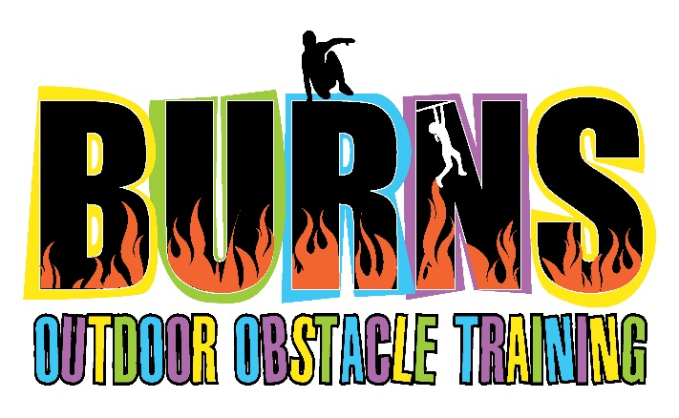

Kids Personal Information
Document

Child Name: Birth date:
Child’s Address:
Parent / Guardian
Home Phone: Mobile Phone: Email:

How did you hear about us?

Photo Release
I hereby give permission for images of my child captured during regular and special activities through video and digital camera to be used solely for the purposes on Burns Outdoor Obstacle Training promotional material, publications, and websites and wave any rights of compensation or ownership thereto. Last name of minors will not be given or posted on the website. I have carefully read this agreement and fully understand its contents.

Parent/Guardian Signature Parent / Guardian Name (please print)

