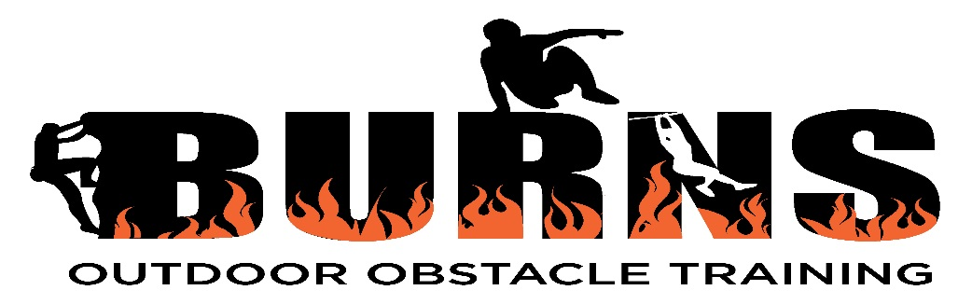
PERSONAL INFORMATION FORM:
Name:
Address:

Phone number:
Date of birth:
Email:
Emergency Contact name:
Emergency contact number:
Your health and fitness goals:

Photo Release
I hereby give permission for images captured during regular and special activities through video and digital camera to be used solely for the purposes on Burns Outdoor Obstacle Training promotional material, publications, and websites and wave any rights of compensation or ownership thereto.
Please place x in appropriate box: Yes No

